INFORMACJA O PROJEKCIE PARTNERSKIM

realizowanym przez Kuratorium Oświaty we Wrocławiu w ramach programu LIFELONG LEARNING (LLP) – Leonardo da Vinci

Współdziałanie regionów europejskich na rzecz wzmacniania internacjonalizacji kształcenia, szkolenia i doskonalenia zawodowego

European Regions Enhancing Internationalization of Vocational Education and Training (EREI-VET)
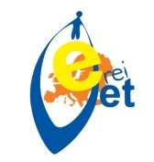



PROJEKT EREI-VET. KONFERENCJA nr 5

Organizator konferencji

Angelika Grande
Ministry of Education of Nord Trøndelag, Norway.

Miejsce konferencji
Britannia Hotel. Dronningens Gate 5, 7011 Trondheim, Norway

PROGRAM KONFERENCJI (AGENDA)

Conference: EREI-VET Partnership 2010-2012
11.- 13. June 2012 in Trondheim, Norway

Date | Time | Who | Action
11. June | Guidebok for Trondheim | Information in your national language here:  http://www.trondheimguide.com/eng/index.html#/English/0 | Arrival of delegations
11. June | 17.00 h  19.15 h  19.30 h  20.00 - 23.00 h | All  All  All  All | Meeting for Coordinators.  Be at the reception.Bus from hotel Britannia to Tyholt Tower.  Common Dinner
12. June | 09.00 - 09.25h | All | Checking in
12. June | 09.30 - 09.45 h | Ministry of Education of Nord Trøndelag, Tore Bruem, Chief Education Department. | Greetings. Welcome
12. June | 09.45 – 10.00 h | Barbara Paulmann, Ministry of Education of Lower Saxony. | Presentation of the objectives of the meeting
12. June | 10.00 - 10.30 h | All | Coffee break
12. June | 10.30 – 12.00 h | Working groups at separated rooms. | 1. Evaluation of the last 2 years (internal evaluation, developping a sheet)  2. Final report (common part)  3. Database EST (European Shared Treasure), website www.ereivet.net and the booklet.
12. June | 12.00 - 13.00 | All | Lunch
12. June | 13.00 - 15.00 | Working groups | 1. Evaluation of the last 2 years (internal evaluation, developing a sheet)  2. Final report (common part)  3. Database EST (European Shared Treasure), website www.ereivet.net and the booklet.
12. June | 15.00 - 15.15 | All | Coffee break
12. June | 15.15 – 16.00 | All | Presentation of the results of the working groups
12. June | 16.00 – 18.00  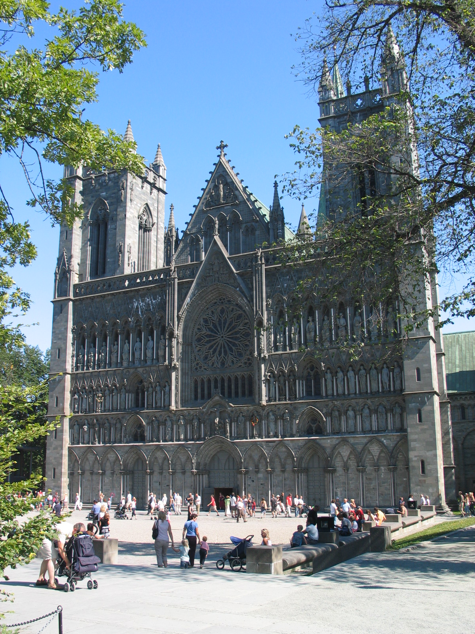 | All  16.45  17.40-18.00 | Walking from Britannia to the Nidaros  (http://en.wikipedia.org/wiki/Nidaros_Cathedral  Guiding tour starting at 16.45 sharp from Entrance (max 45 min).  Music Concert in Nidaros (for you, who are interested)
 | 18.45  19.00 | All  All | Aperitif at the bar.  Hotel Britannia. Education Department NTFK. Official Dinner.
13. June | 08.10  08.45 | All (check out from hotel for persons who are flying home today). The school we will visit now situated at the same city as Airpot Værnes. | Bus leaving to Stjørdal.  Visit at Ole Vig Upper Secondary school.
13. June | 08.10  08.45 | All | Stjørdal, Ole Vig Upper Secondary school
13. June | 09.00 - 09.30 | Headmaster, Anders A. Hov  International Coordinator, Tore Larsson | Welcome  Presentation of the school and International work at the school
13. June | 09.30 - 10.15 | International Coordinator , Tore Larsson | Tour at the school, presentation of 3 workshops for professional study and training.
13. June | 10.15 - 10.30 | All | Coffee break in school
13. June | 10.30 - 12.00 | Barbara Paulmann  All Coordinators  Gernot Grinschgl / Styria | Summary.  Thank you, EREI-VET!  Looking back, slideshow: EREI-VET, 2010-2012
13. June | 12.00 - 13.00 | All | Lunch
13. June | 13.00 - 13.10 | Departure from school to Airport (10 min. trip) | Arriving Airport for the departure.  Have a save trip home☺
 | 13.10 | Good bye! | See you again !!

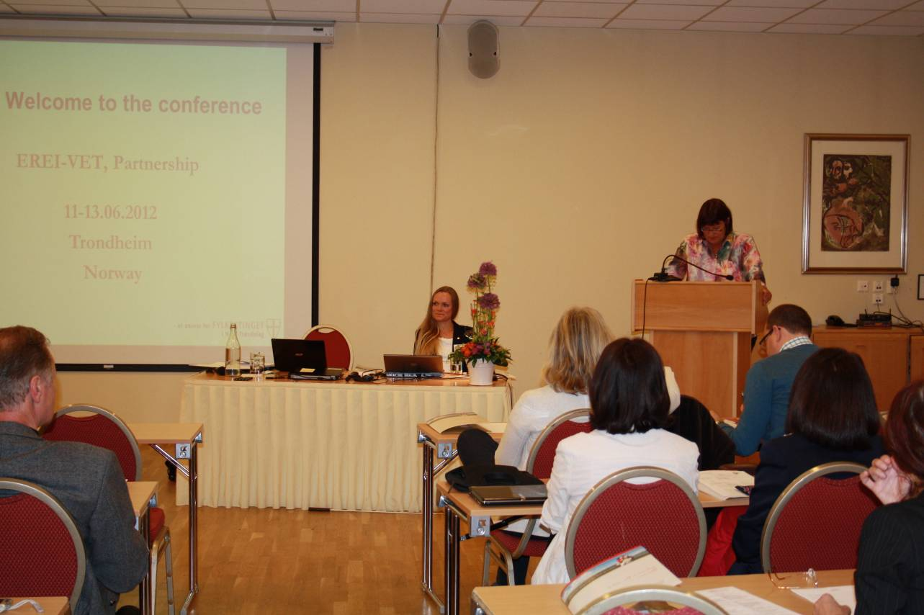
Trondheim 2012.
Oficjalne otwarcie konferencji. Angelika Grande i Barbara Paulmann.

Uczestnictwo beneficjentów projektu z regionów (oficjalni partnerzy w projekcie):

1. Andalucia/Spain
2. Apulia/Italia
3. Champagne-Ardenne/France
4. Frisia/Netherlands
5. Greater Poland/Poland
6. Lower Silesia/Poland
7. Lower Saxony/Germany
8. North-Trondelag/Norway
9. North-Rhine Westfalia/Germany,
10. Provence-Alpes-Côte d’Azur/France.

Regiony, które dołączyły do projektu już w trakcie jego realizacji i uczestniczą w nim w ramach środków własnych – nie są beneficjentami projektu (nie mają wsparcia finansowego Komisji Europejskiej):

11. Jamtland / Sweden
12. Raisio / Finland
13. Rouen / France
14. Sjaelland / Denmark
15. Styria / Austria
16. Upper Normandy / France

Reprezentacja Dolnego Śląska:

Beata Pawłowicz, Janina Jakubowska, Adam Gardynik, Jan Kamiński.

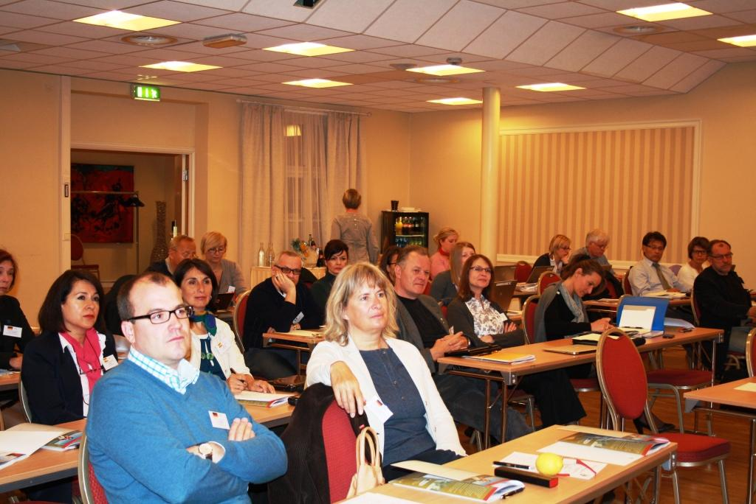
Trondheim 2012. Sala obrad.

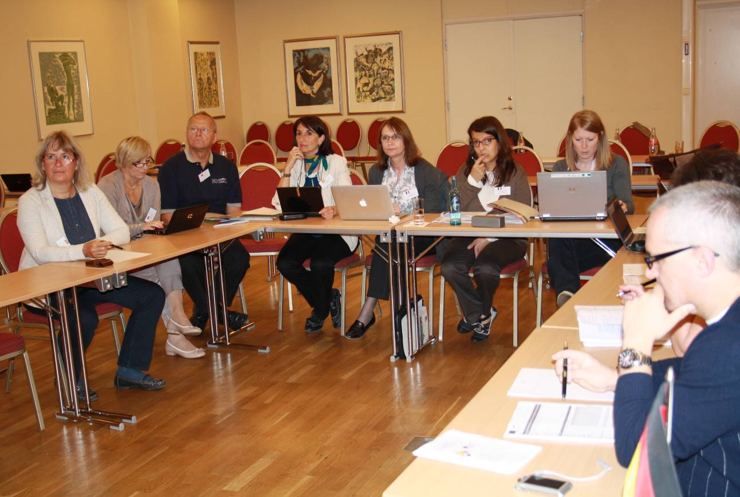
Trondheim 2012. Obrady grupy roboczej. Cornelia Rückert (de), Beata Pawłowicz (pl), Jan Kamiński (pl), Angeles Gabella Barro (es), Monique Parizot (fr), Sandrine Puppini (fr), Emélie Boyer (fr), Settimio Antonio Romei (it).

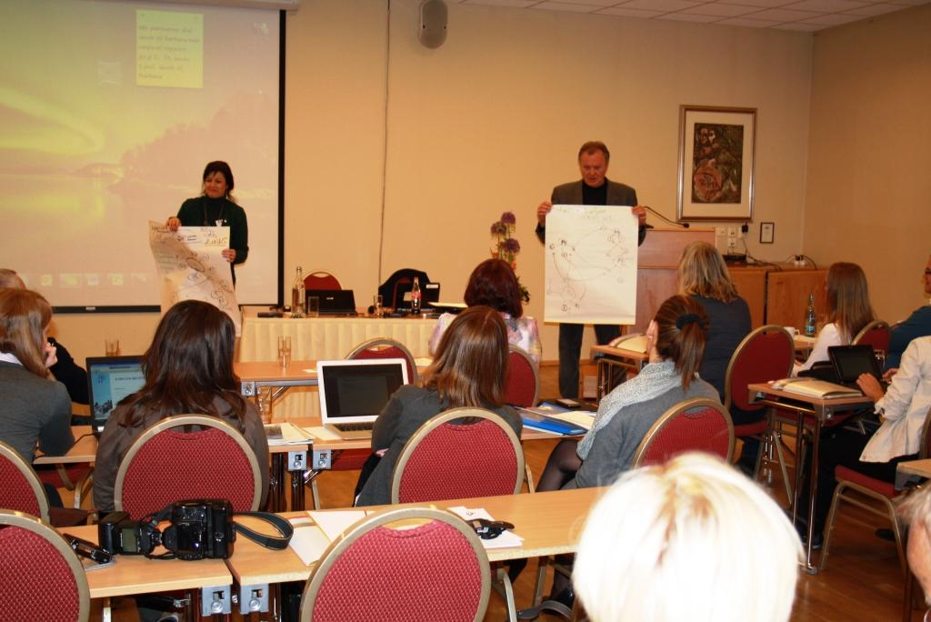
Trondheim 2012. Prezentacja wyników prac I grupy roboczej. Adele Citano (it) oraz Gernot Grinschgl (at).

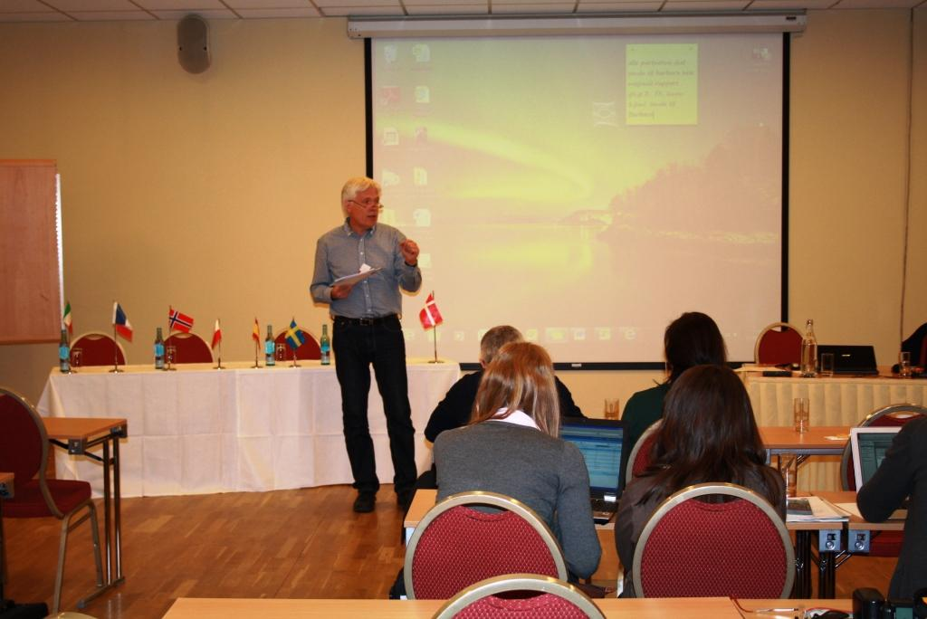
Trondheim 2012.
Prezentacja wyników prac II grupy roboczej. Christopher Harnischmacher (de).
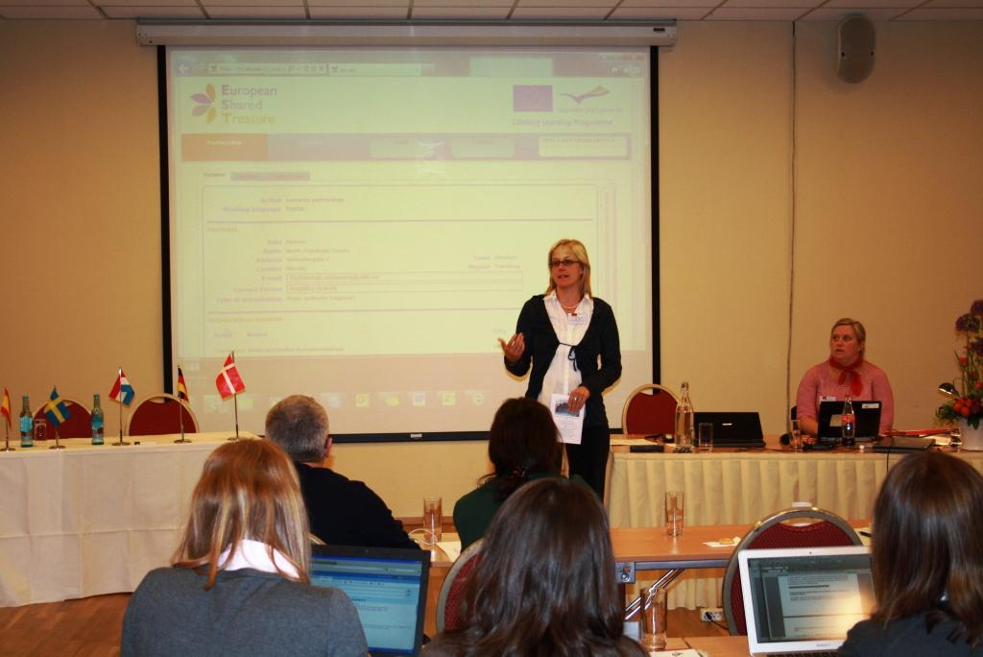
Trondheim 2012.
Prezentacja wyników prac III grupy roboczej. Barbara Lindstaedt (de).

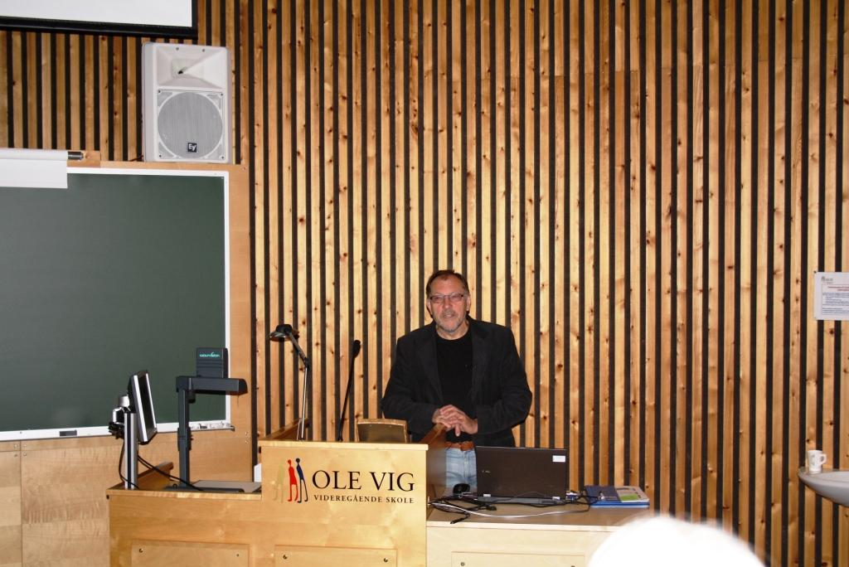

Trondheim 2012. Wizyta w szkole zawodowej OLE VIG (Upper Secondary School) w Stjørdal. International Co-ordinator - Tore Larsson.

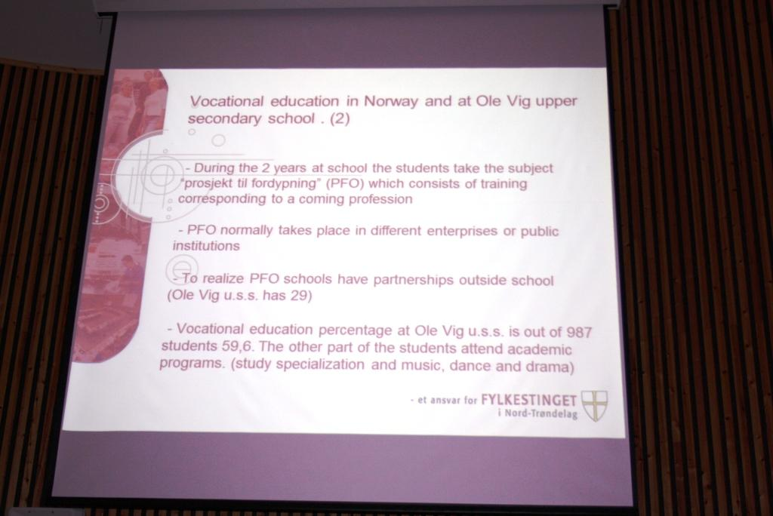
Trondheim 2012. Informacja o szkole OLE VIG w Stjørdal.

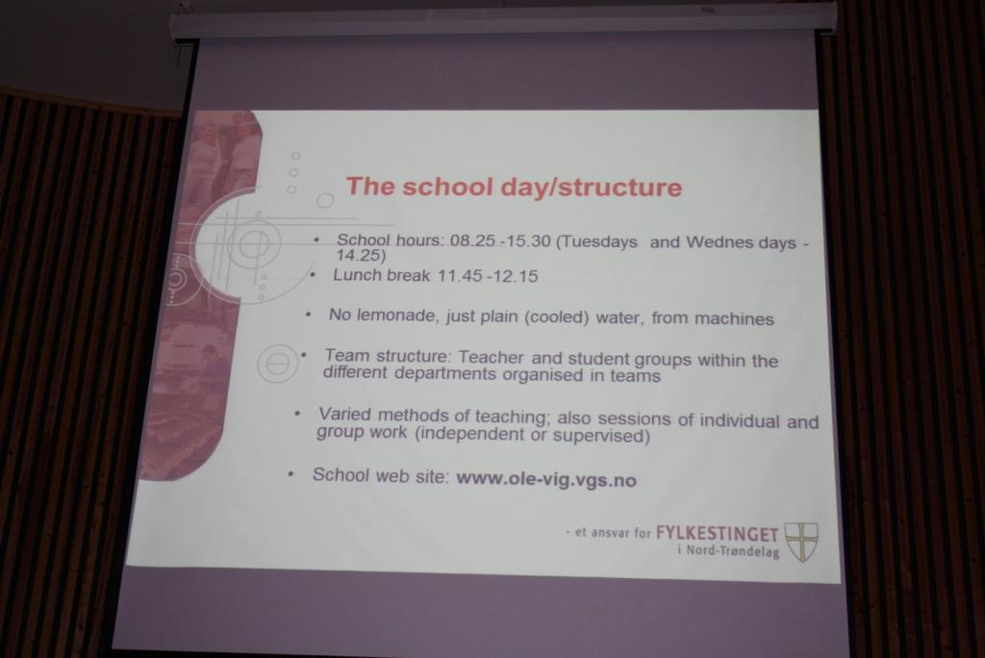
Trondheim 2012. Informacja o szkole OLE VIG w Stjørdal.

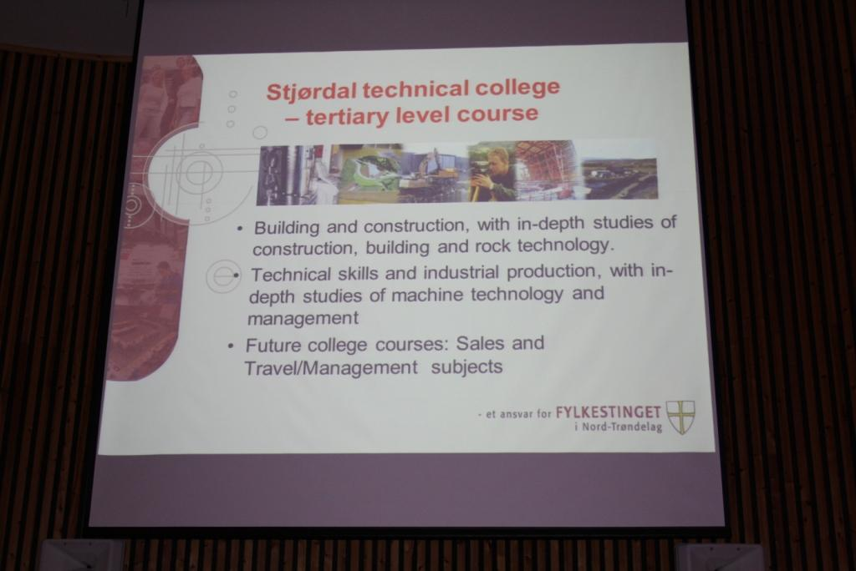
Trondheim 2012. Informacja o szkole OLE VIG w Stjørdal.

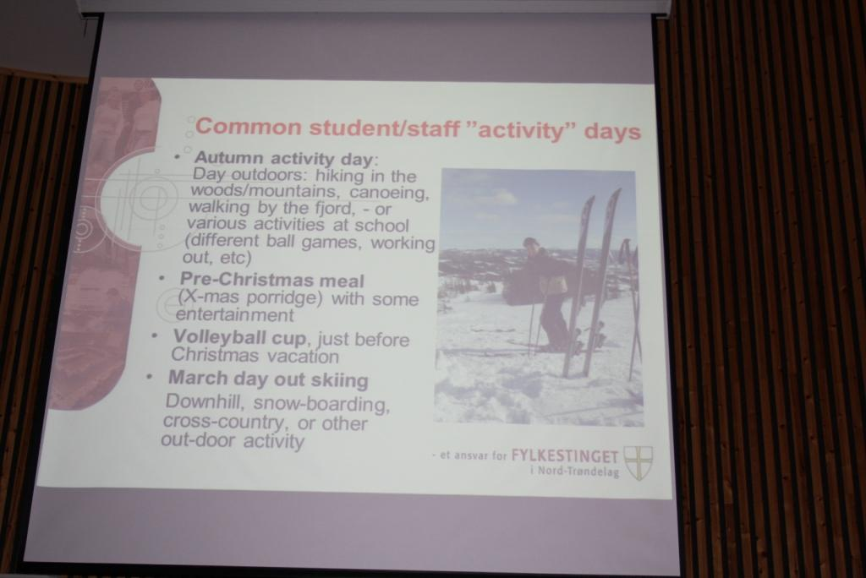
Trondheim 2012. Informacja o szkole OLE VIG w Stjørdal.

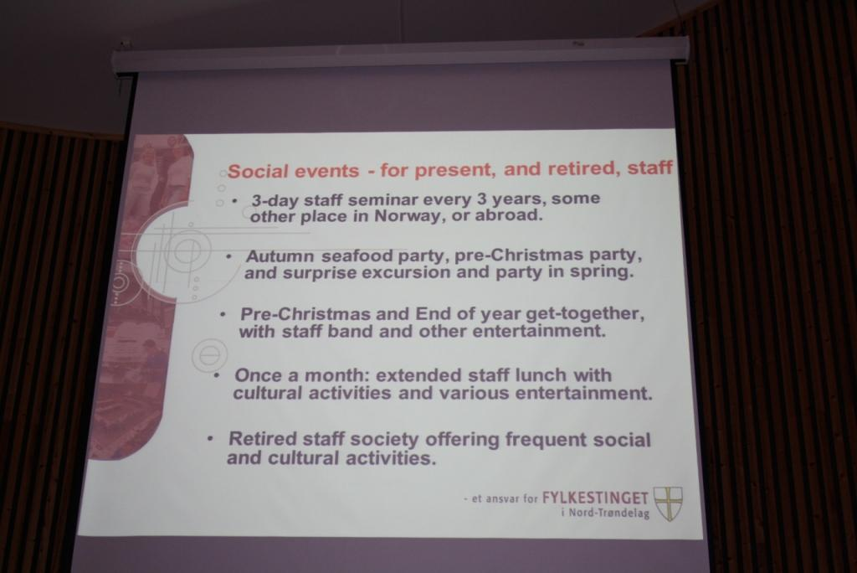
Trondheim 2012. Informacja o szkole OLE VIG w Stjørdal.

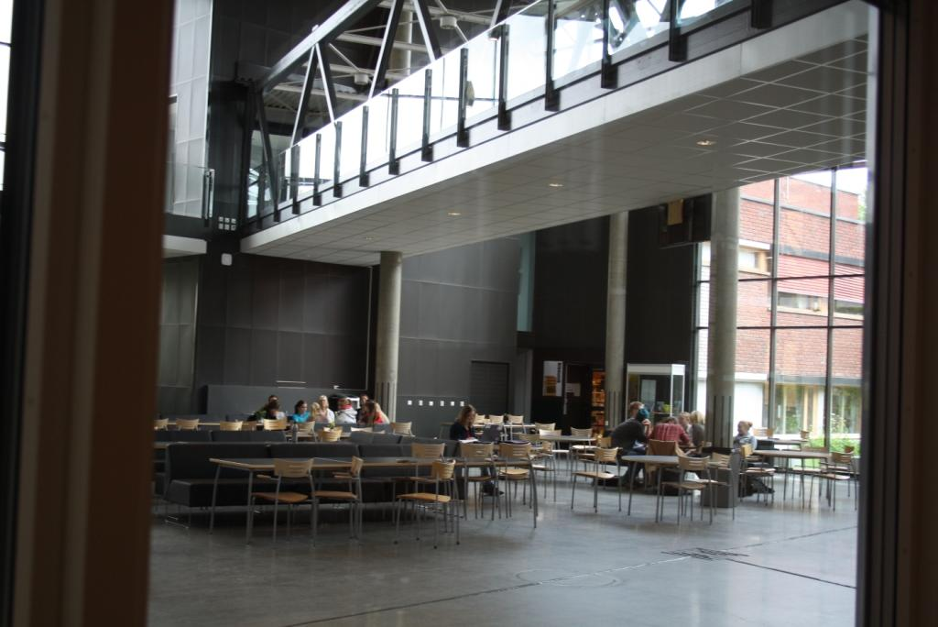
Trondheim 2012. Szkoła OLE VIG w Stjørdal. Stołówka.

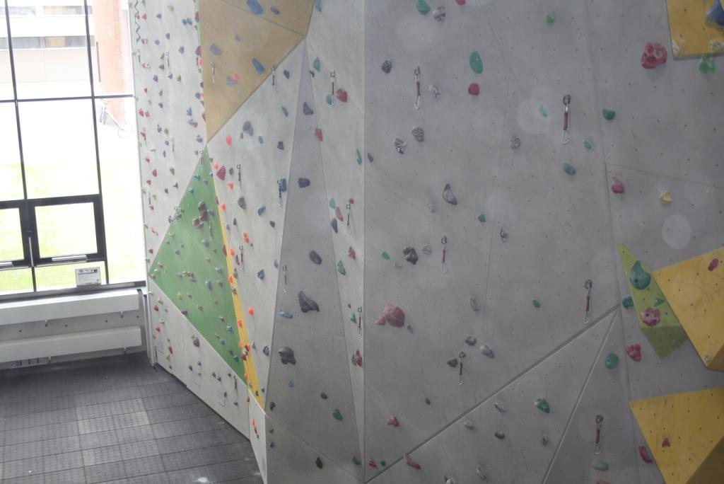
Trondheim 2012. Szkoła OLE VIG w Stjørdal. Ściana wspinaczkowa.

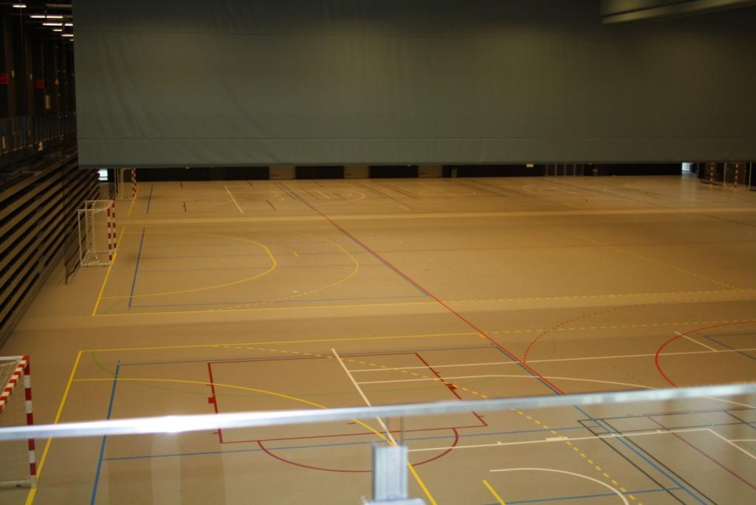
Trondheim 2012. Szkoła OLE VIG w Stjørdal. Obiekt sportowy.

CONFERENCE REPORT
Meeting for coordinators
Discussion on the agenda and the objectives of the meeting:
- Evaluation of the different aspects of the partnership based on mid-time evaluation
- Input EST database
- Work on final report – discussion from July until September
- To prove if all confirmations of attendance are available and formally correct
Welcome and opening of the conference
Introduction by Angelika Grande
Video Message by Tore Bruem, Chief Education Officer, North-Trøndelag County, Norway: Mr. Bruem welcomed the audience and underlined the extraordinary meaning of Europass, EQF, ECVET, EQUARF for a single market, for free movement inside Europe. (attachment 3: welcome speech
Objectives of the meeting (Barbara Paulmann, Ministry of Education of Lower Saxony)
New application: answer by commission until August, 1. Conference in Apulia; plan B: Feb 2013 new trial
Lot of work last year.
Development of the Website, Work on the content of the website, opening of the internal site to the Commission
Important: Integration of partners which are not in the project: SE, AT, DK, FI, TR
- Evaluation of the different aspects of the partnership based on mid-time evaluation
- Input EST database
- Work on final report – discussion from July til September
- To prove if all confirmations of attendance are available and formally correct
Working groups and presentation of the results of the working groups by workgroup speakers
- The group members continue the evaluation of the last 2 years which is for the publication on the website. The group compares the questions/points of the final report and the evaluation the project made last year. The group decides the main points of interest for the public (the schools who will visit the website). The group adds some comments about the internal communication. (see paper attached; participants: Philipp, Christian, Adele, Silvia, Jan, Gernot, Christoph, Marie Piere, Annette)
- Discussion about results and products, development of the idea of “EREIVET success stories”
- Collecting wishes, changes for the future
- Browsing the content
- Presentation and assessment oft the outcomes
- Work on final report (common part) for the LEONARDO DA VINCI partnership project. The group writes a draft of part A of the final report for later discussion. (see final report) browsing through final report form comparing text of application with input into the fields of the final report. Especially we discussed the EUROPEAN ADDED VALUE:
The participating partners upgraded their practice in mobility in vocational educational training through:

- exchanging of transnational experience and examples of good practices,
- the recognition of competences and qualifications: use of Europass instruments and the promotion of ECVET and EQF (e .g. during the conference in Lüneburg),
- introducing a good strategy for mobility and exchange, and installing quality assurance in mobility (e. g. check lists for organizing mobility, manual about quality in mobility)
- better knowledge about European school systems and exchange of good practices about mobility (comparison of the European education system for VET colleges with different information from each country involved),
- project meetings to create common European tools for mobility in vocational educational training,
- practicing intercultural dialogue and enhancing the cooperation between European VET schools through mobility projects,
- widening the EREIVET network (extension of the cooperation to 16 partners underlining the European dimension of the project)

Institutions involved

- sharpened their profiles in being involved in international activities,
- made the different educational formations of the countries visible and more transparent through mutual collaboration,
- encouraged the quality of the educational streams in the participating colleges and institutions,
- increased the professional development of the staff,
- motivated student’s and teacher’s mobility and the European appeal of the institution,
- supported vocational educational colleges which are attractive for their teachers and for their students.
Teachers and trainees involved increased their professionalism by

- strengthening their personality and communicative skills,
- exchanging ideas with professionals from different European countries,
- reflecting on modern target group oriented models for mobility,
- using some materials and methods to encourage mobility.
Finally we decided to do some ‘homework’
- F.3, G.1, G.2 form all to Barbara until 1 July 2012
- Barbara will send available text
- CH finalize Text European Added Value for the final report
- Barbara will be editor of part A
- some explanation/ hints on Part A and B
- Barbara will sent evaluation questionnaire to all partners (see attachment)
- This working group browses through Database EST (European Shared Treasure) and website www.ereivet.net. to see what is yet published on the database and on EREIVET homepage. The group decides to add the following points/topics as tasks for everybody
This group had three tasks:
- Collect input for the database EST (common part) Regarding EST database, the contributions claimed as a common result are shared by all the countries. They have to be translated by each country into national language. The group developed a TODO list (see attachment). The national contributions have to be entered by country.
- Evaluate the website EREI VET to finalize it as product of the project (see attachment as TO DO list for all participating countries)
- Evaluate the brochure (see attachment with TODO list and proposals)
Visit in Stjørdal, Ole Vig Upper Secondary school
Welcome; Presentation of the school and International work at the school by Headmaster, Anders A. Hov and International Coordinator, Tore Larsson.
Guided school tour and presentation of 3 workshops for professional study and training.
Summary of the meeting / conclusions
- -Looking back, slideshow: EREI-VET, 2010-2012

Conference Report by Christopher Harnischmacher

Projekt został sfinansowany przy wsparciu Komisji Europejskiej w ramach programu „Uczenie się przez całe życie”. Publikacja przedstawia wyłącznie poglądy jej autora. Komisja Europejska oraz Narodowa Agencja programu LLL nie są odpowiedzialne za jakąkolwiek formę użycia informacji zawartych w treści tej publikacji.

